Groundwork Project
Developer Guide
Richard Lui

Introduction:
This document serves as the developer guide for the Groundwork project: an AI-based solution in testing, artifact generation, and knowledge extraction for codebases. The current project is based upon a multifaceted knowledge base that supports dependency graphs, business rule extraction, file metadata, and file similarity vectors.
The purpose of this document is to help teammates, and future contributors on how to understand and utilize the Groundwork codebase.

Project Overview:
How can we modernize the Development, Testing & QA, and Release stages of the Software Development Life Cycle?
The Groundwork project explores a common software engineering problem – the development bottleneck that appears while creating and executing tests. Writing comprehensive test suites becomes increasingly difficult as codebases get larger, and developers require context on linked files, repository function, and potential weaknesses.
Groundwork uses AI to extract knowledge and metadata from each file in a repository, and then automate weakness reports, dependency graphs, and test suite generations with context.
Core Features:
- File dependencies extracted from file headings and stored in Kuzu Graph Database
- Metadata on each file extracted and stored in PostgreSQL Database:
  - Language
  - Classes
  - Methods
  - Attributes
  - Functions
  - Lines of Code
- Business Rules extracted from each file and stored in PostgreSQL Database:
- Key Points – up to 15 generating by condensing business rules from each file; meant to encapsulate repository function
  - Key Points used to generate Vector Embeddings for each file
- Vectors generated for each file that summarize files contribution to overall codebase function stored in Chroma Vector Database
- UML Diagrams depicting file metadata
- Graphs depicting dependency relations
- Weakness reports denoting file vulnerabilities upon test generation
- Unit Test generation based on Retrieval Augmented Generation (RAG) principles

Workflows and Use-Cases:
Use-Case | How it is Used | Why it Matters
Test Generation | Use the TUI to generate a unit test on a specific file in the repository | Developers will be able to have a context-based unit test to begin tests off, and a weakness report to make any adjustments to file.
Artifact Generation | Use the TUI to generate a UML diagram depicting file contents, or a graph depicting dependency relationships | Developers will be able to have visual representations of repository. Useful in presentations or for new developer onboarding

Workflow Diagrams:
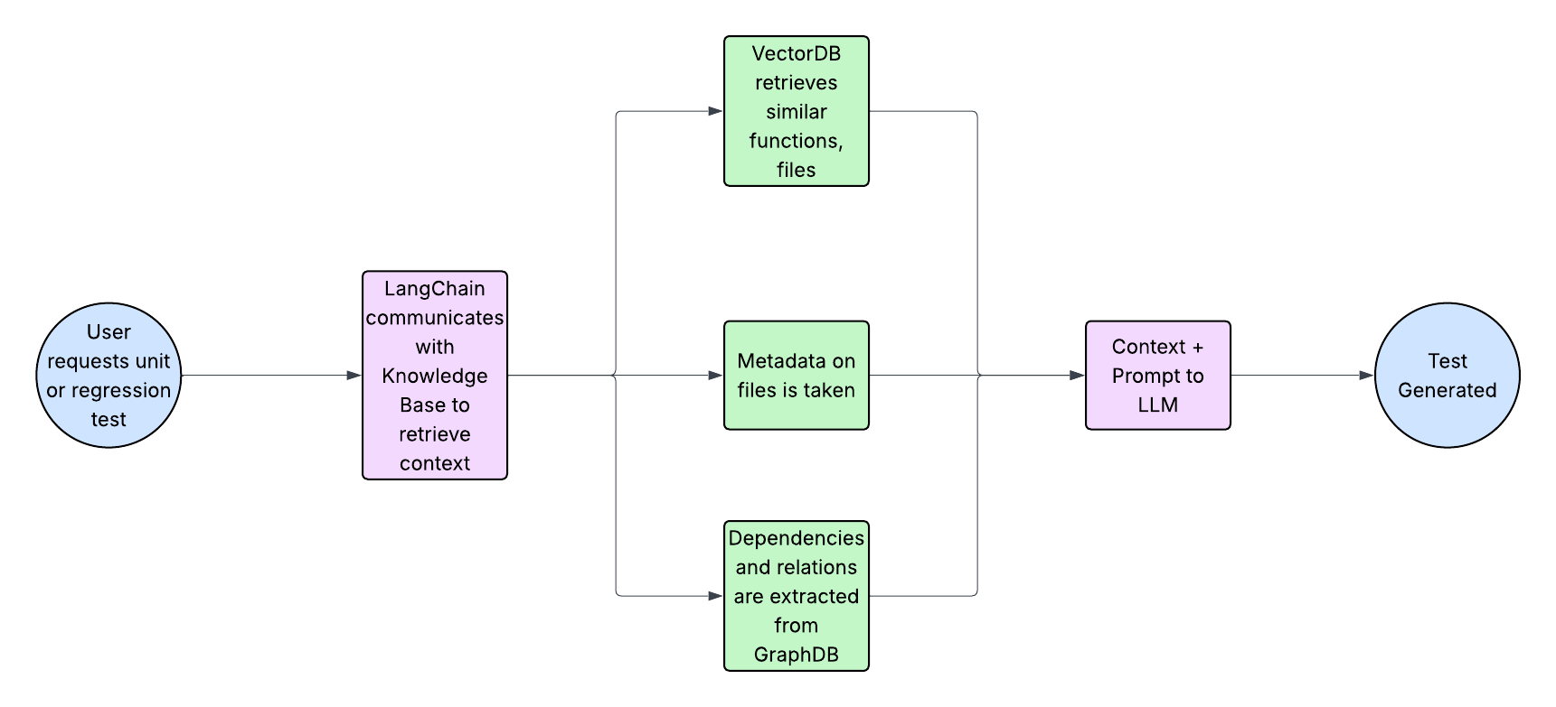
Figure 1: Workflow for Test Generation
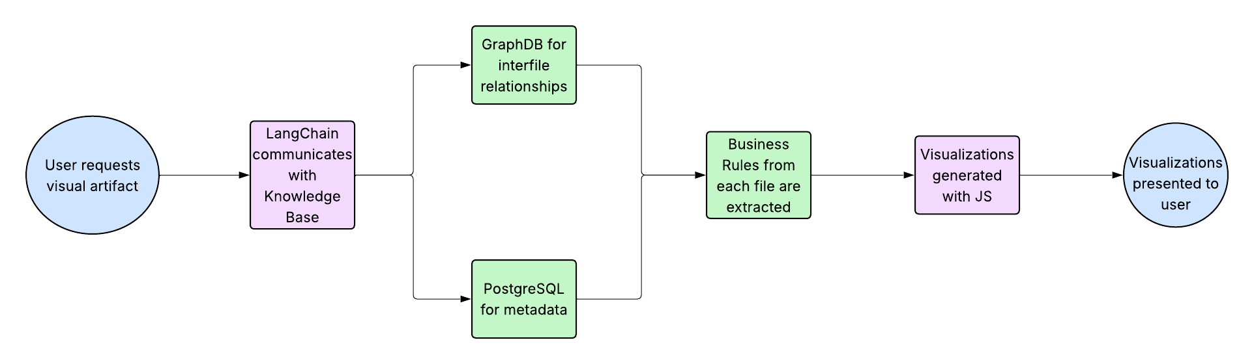
Figure 2: Workflow for Artifact Generation
Use-Case Examples:
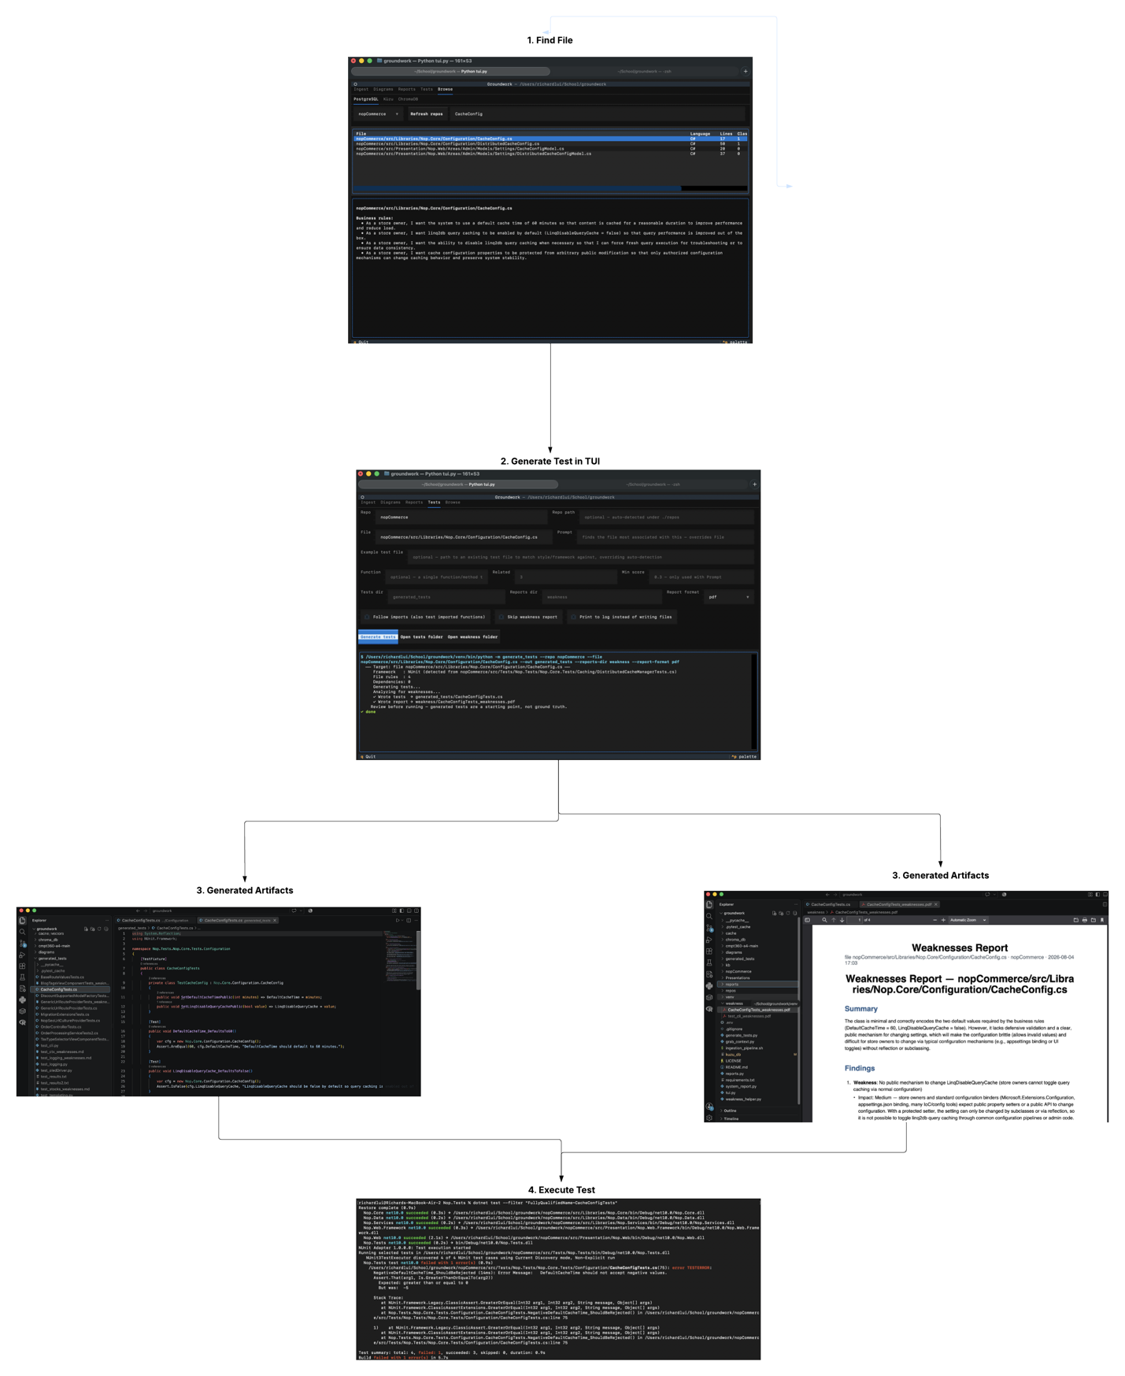
Figure 3: Test Generation

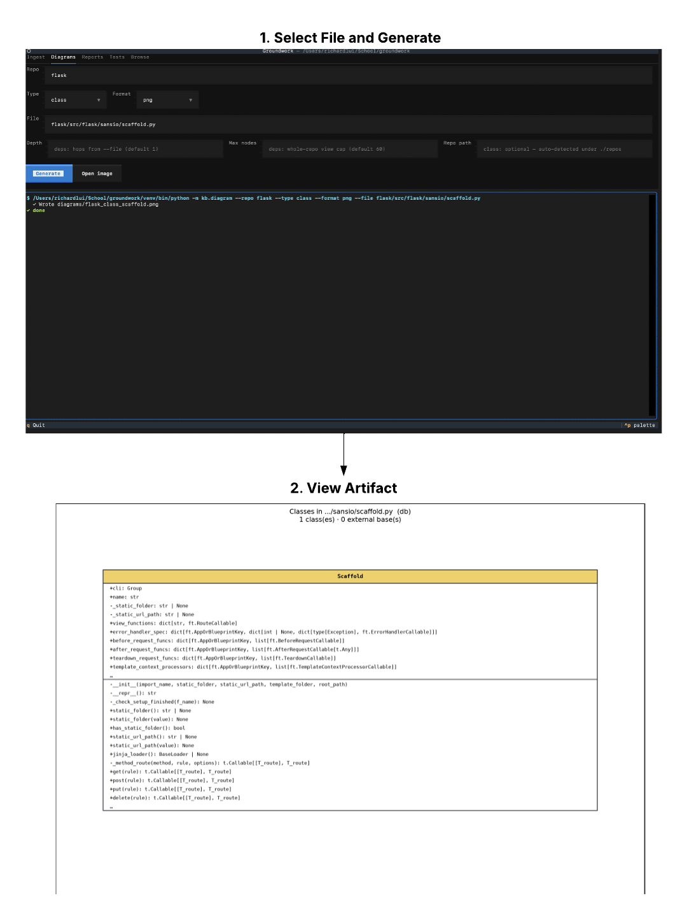
Figure 4: UML Diagram Generation

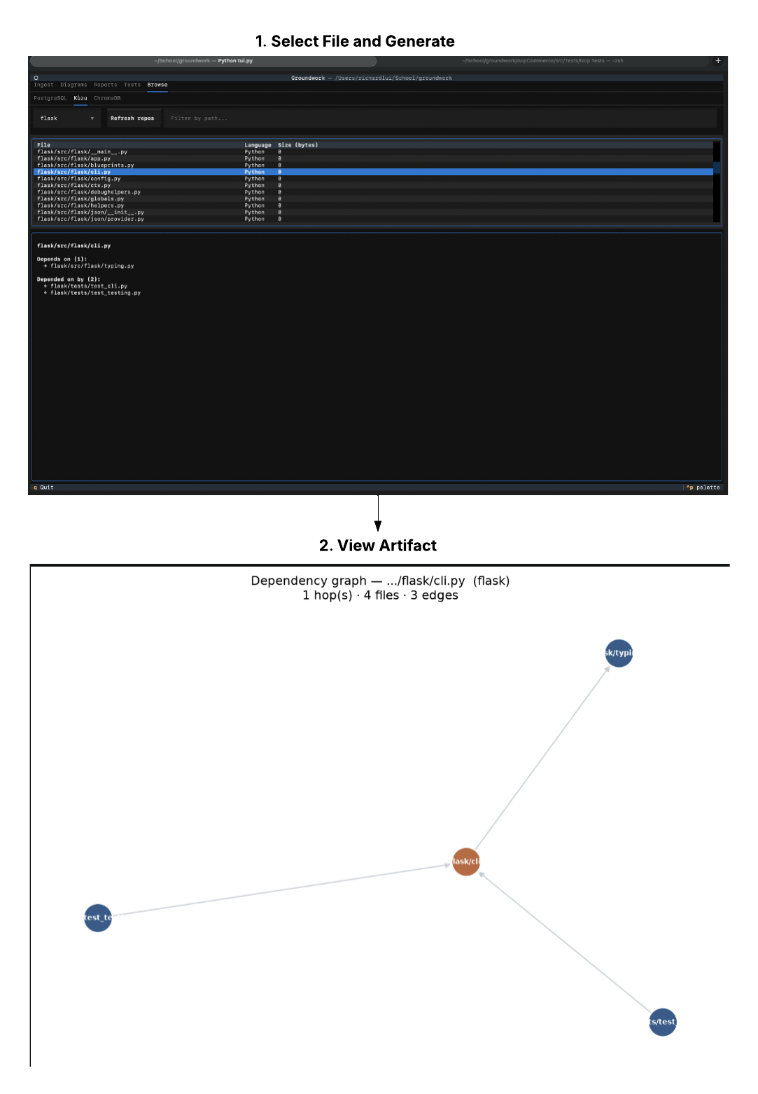
Figure 5: Dependency Graph Generation

Detailed Design:
Architecture Overview:
Groundwork is consisted of 3 layers:
- Front-End Layer: TUI by which user interacts with services
- Orchestration Layer: API that communicates with Front-End and Knowledge Base written in Python. LangChain grabs context and coordinates with LLM’s.
- Knowledge Base Layer: Consists of Graph Database, Vector Database, and Relational Database with information on uploaded repositories

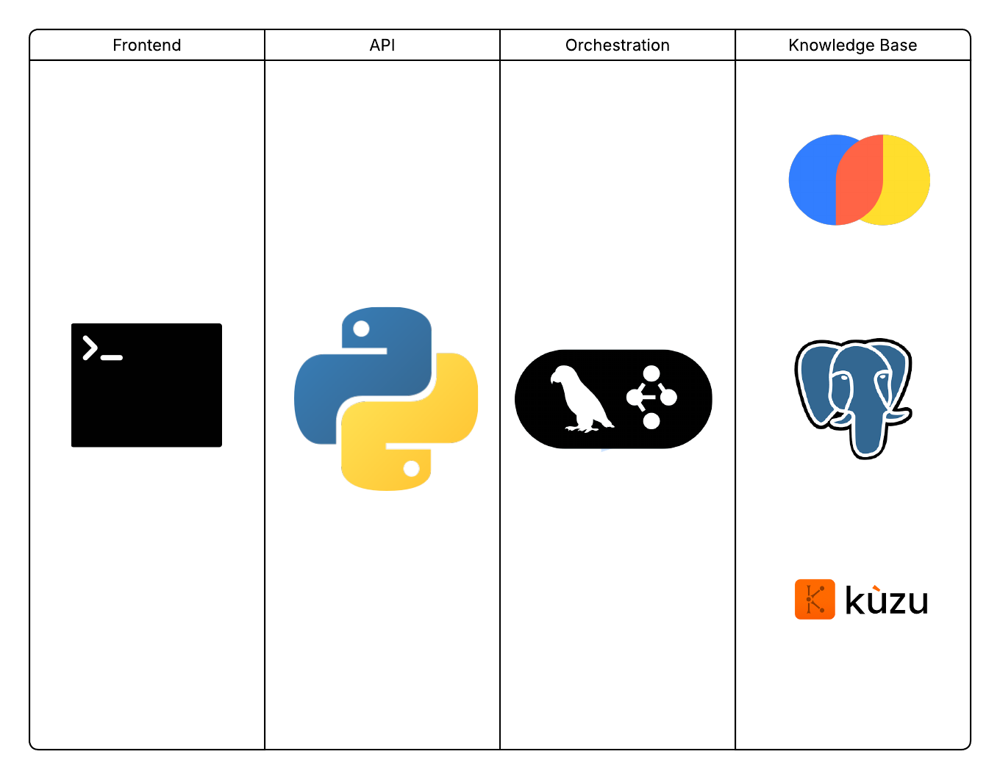
Figure 6: High Level Design

Front-End:
Terminal User Interface that includes all facets of Groundwork. Consists of 5 panels:
- Ingest: Repositories can be uploaded using GitHub link or specifying location
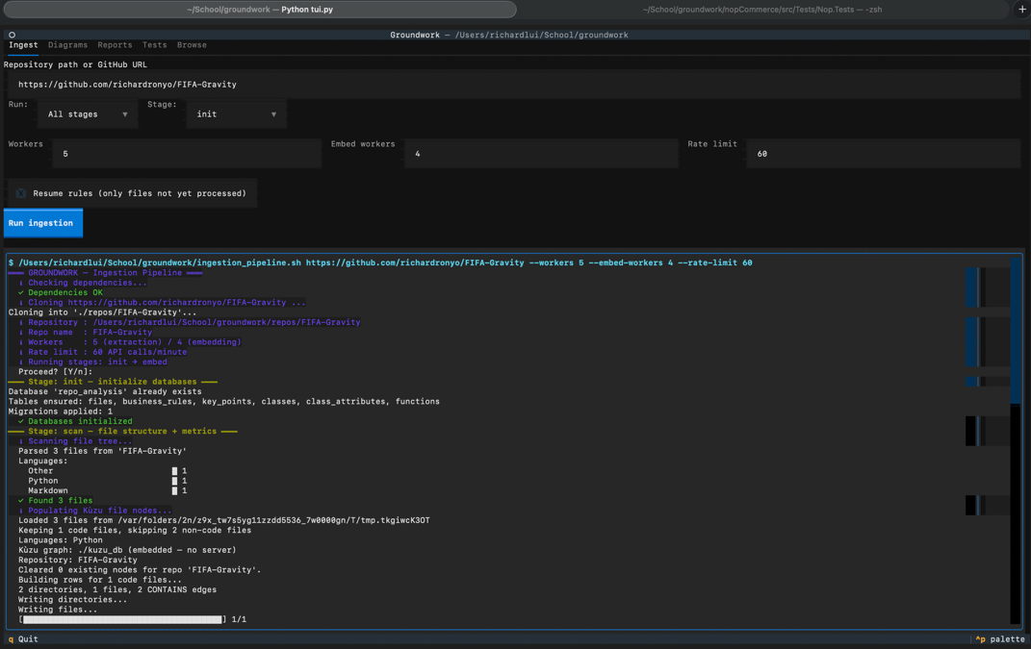
- Diagrams: Generate UML diagrams on file metadata or Graph diagrams on file dependencies
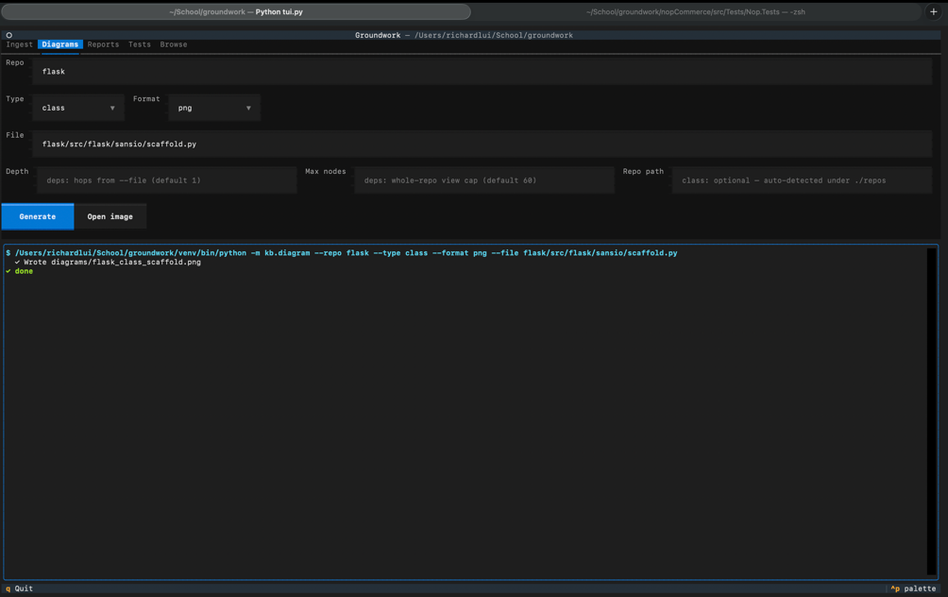
- Reports: Generate reports on entire repository or singular file. Incomplete and non-functional

- Tests: Generate unit tests based on prompts or file input
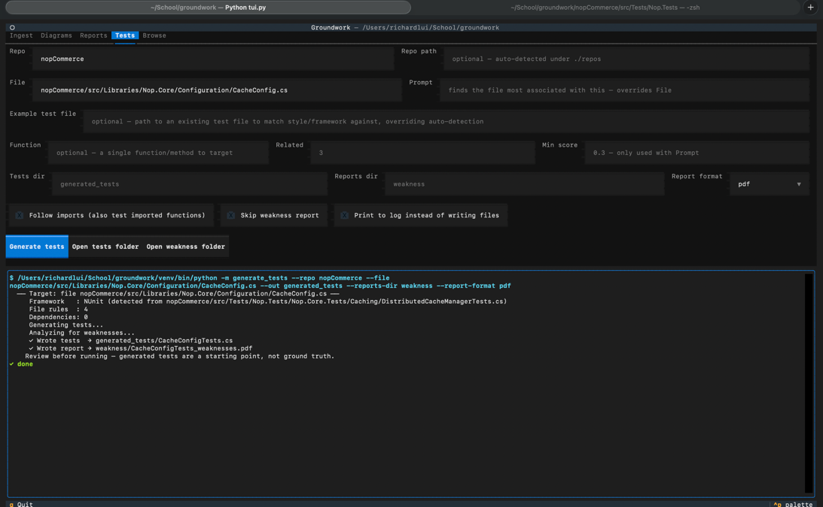
- Browse: Browse contents of the Knowledge Base
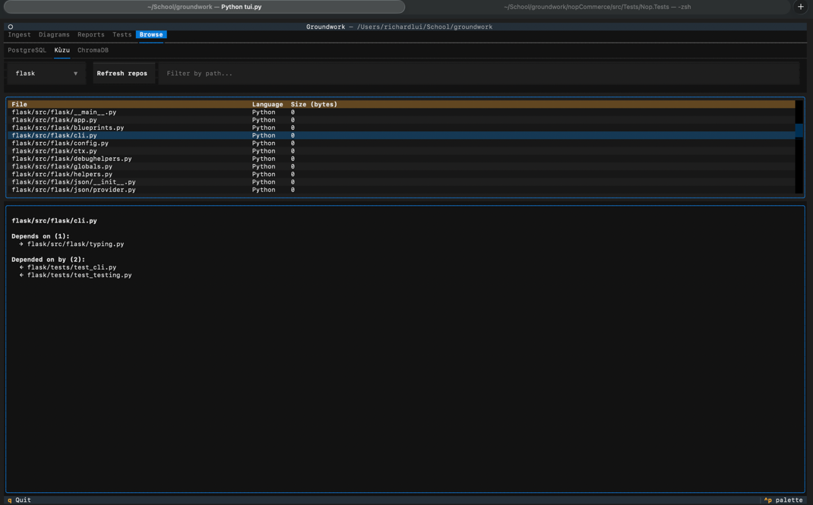

The front-end is entirely defined in tui.py. Execution steps will be detailed in a later section.

Orchestration Layer:
The Orchestration Layer sits above the Knowledge Base layer and coordinates across stores to answer a question, ingest repositories, or produce artifacts.
Key Files:
- grab_context.py – Uses vector embeddings to grab files related to query or request, along with business rules, key points, and metadata
- generate_tests.py – Gathers context and generates test on specific file. Traverses’ repository for test file if existing test file is not provided. Uses test file to determine testing framework/conventions
- ingestion_pipeline.sh – Used to ingest a repository to the Knowledge Base
- api.py – Used to view contents of knowledge base components
- kb.diagram.py – Used to generate UML and Graph diagrams of files
Knowledge Base Layer:
The knowledge base consists of 3 stores:
- Relational Database (PostgresQL): Stores business rules for each file, key points that encapsulate the repository’s function, and metadata that includes:
  - Language
  - Classes
  - Methods
  - Attributes
  - Functions
  - Lines of Code
- Graph Database (Kuzu): Stores dependencies from file to file, and repository structure
- Vector Database (ChromaDB): Vectors for each file with semantic relation to each key point, calculated using BERT scores. Used to query knowledge base for context based on request/test file.

Relational Database:
Each file that is ingested has metadata extracted using kb.parser.py to extract the above metrics.
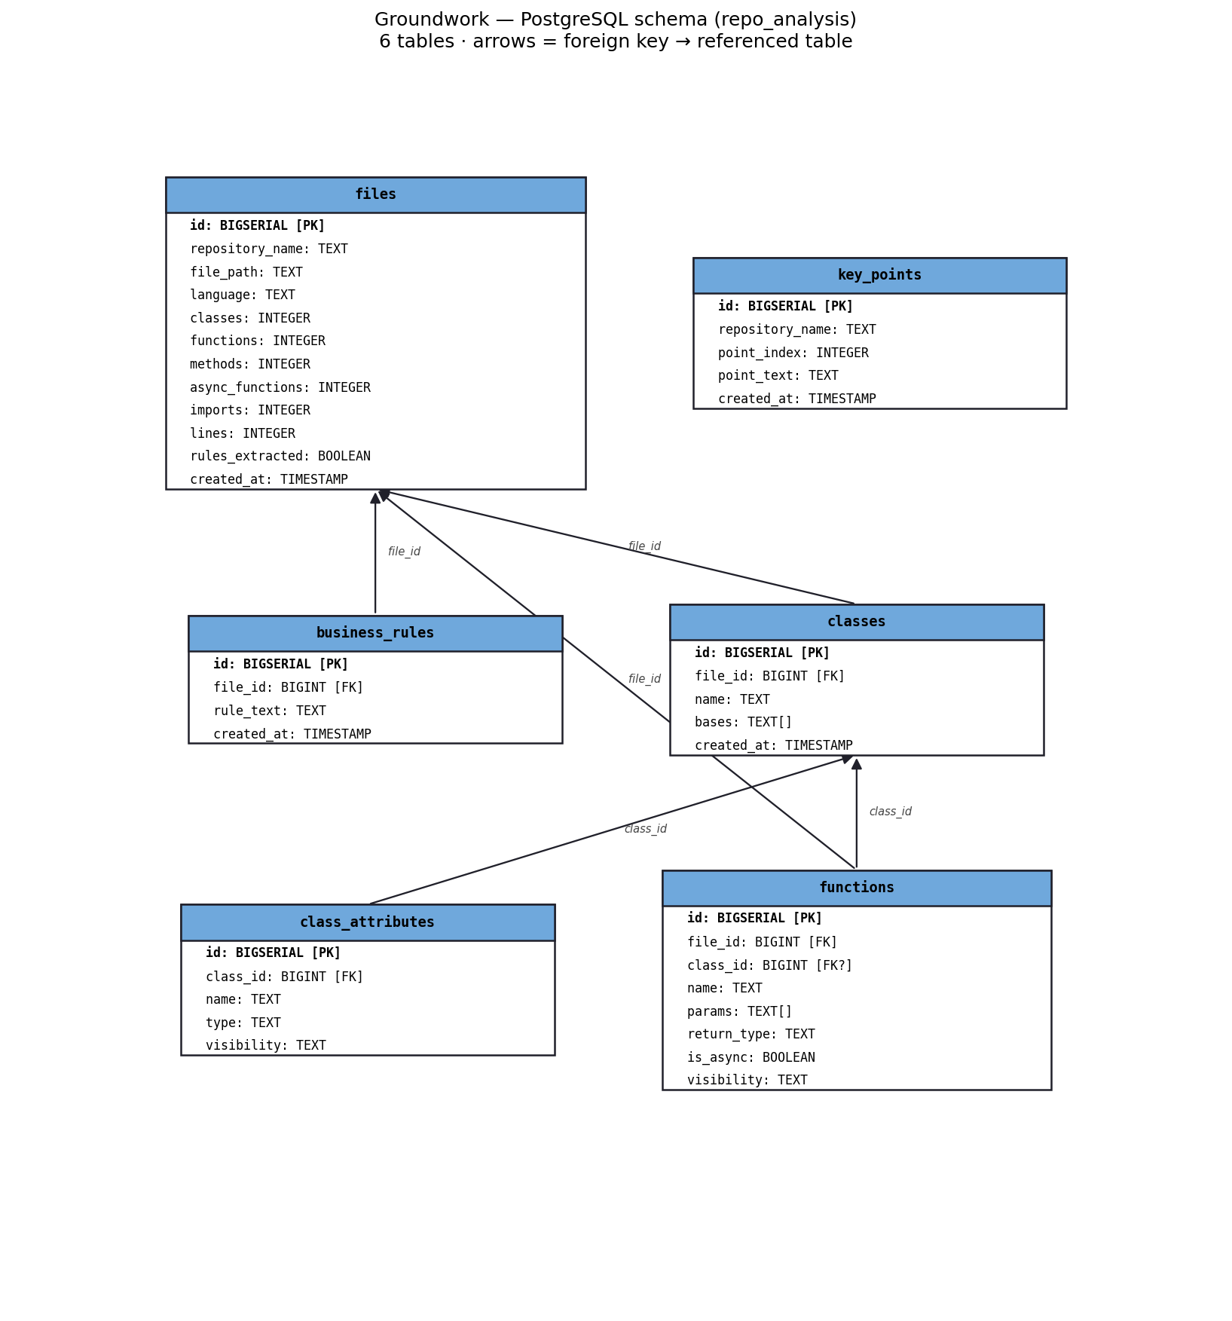
Figure 7: Database Schema

Graph Database:
Kuzu database that tracks dependencies and repository structure.
Repository structure is extracted by converting a “file tree”to a JSON. Key files include kb.graph.tree_to_json.py, kb.graph.tree.json_to_graph.py.
Dependencies are tracked by parsing through the first N lines in the file extracting imports and comparing to files in repository.

Vector Database:
Chroma Database that contains a vector for each file in the repository. Each column per vector depicts relation to a Key Point. Key Points are generated by the LLM by synthesizing the Business Rules extracted from each file.
To calculate the vector for each file, a BERT score for each business rule is calculated against each key point. The final vector contains the average BERT score for the business rules belonging to a file against the Key Points.
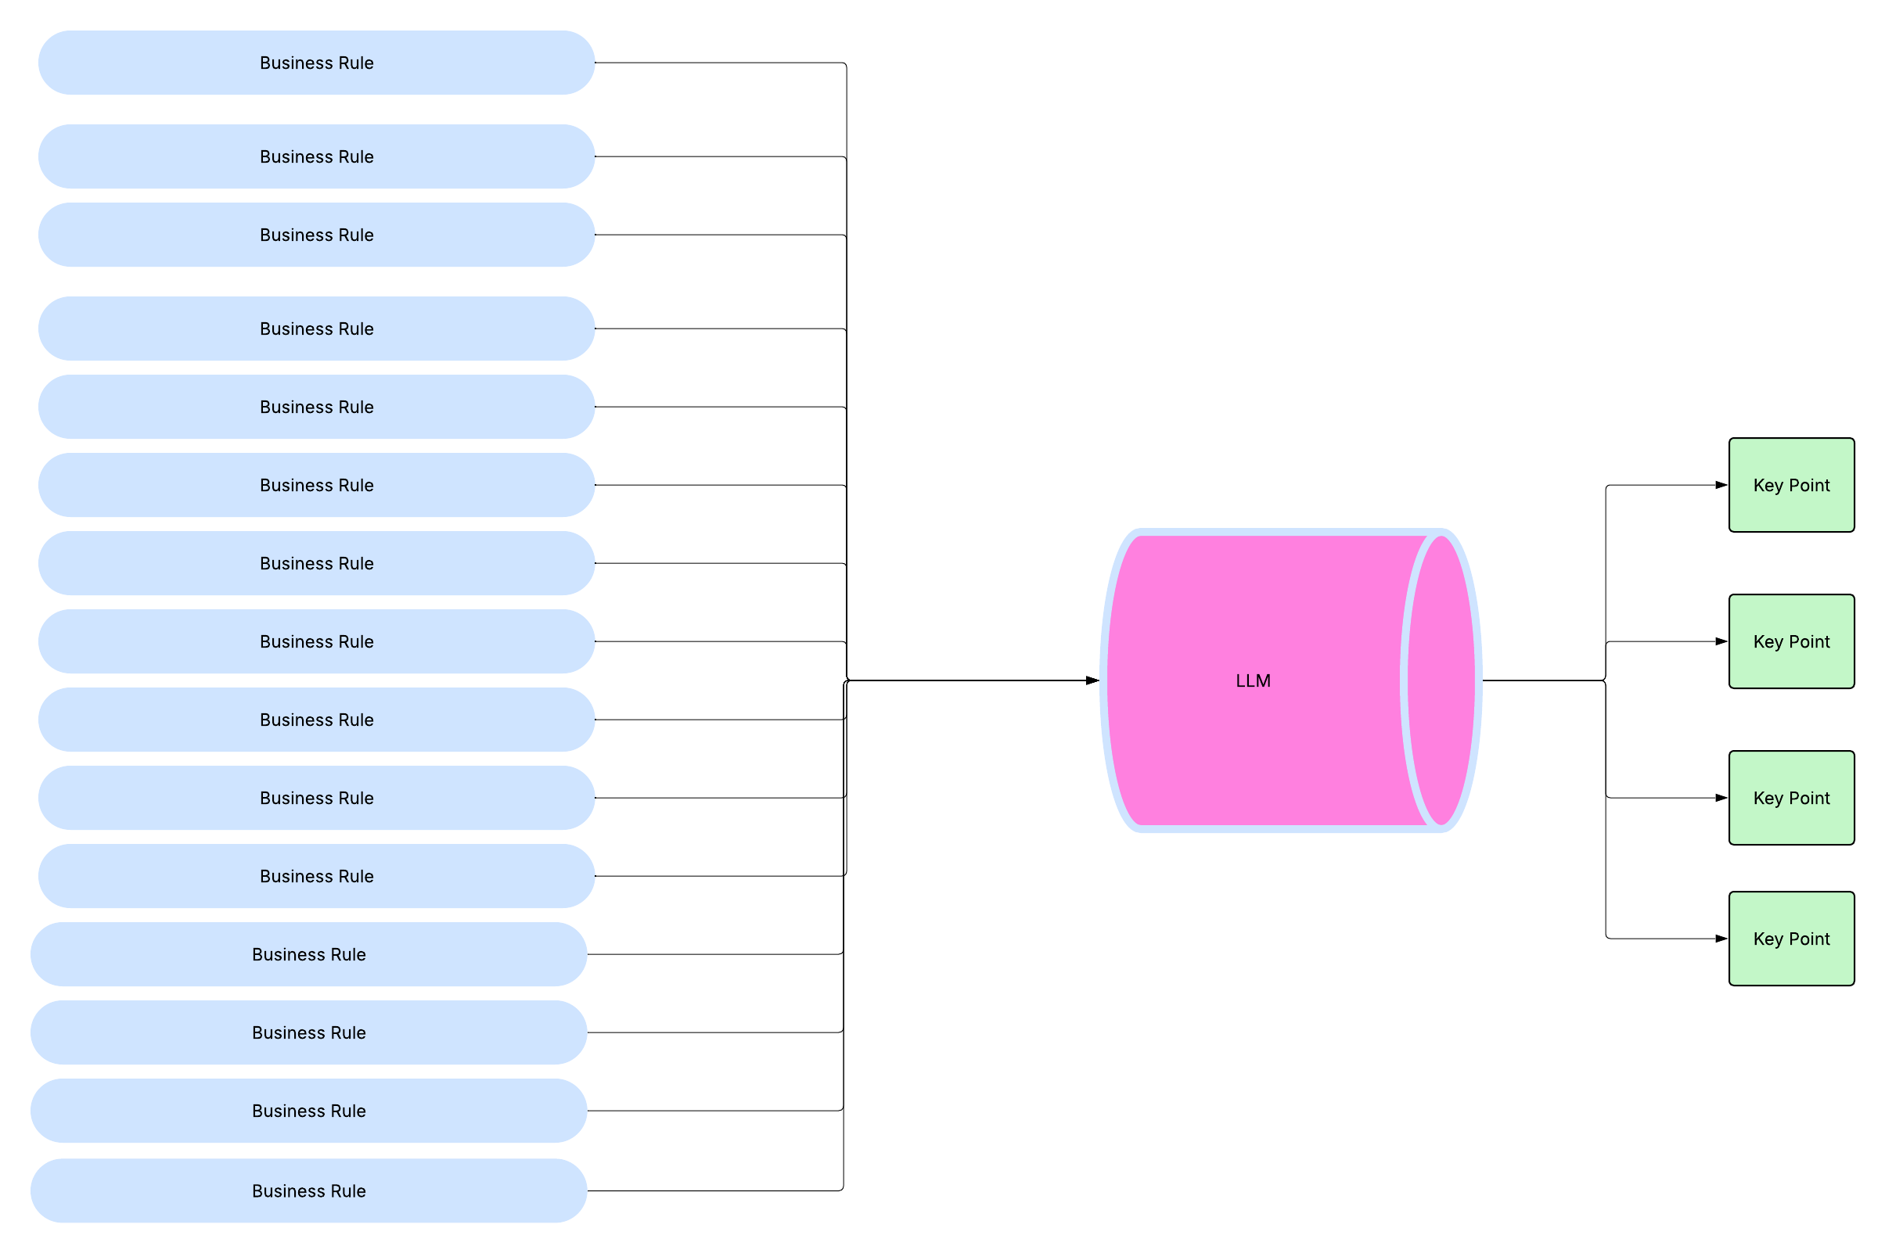
Figure 8: Business Rule to Key Point logic

